- Many in the maritime field see AI as a practical tool that strengthens shipboard operations—helping reduce administrative tasks, improve safety, and support smarter decision‑making—while still relying on mariners’ expertise where it matters most. To discuss this impact,
Please join me in welcoming Fares Al‑Salim, a Senior Product Manager in the Data and Analytics group at the American Bureau of Shipping. With over seven years of experience developing data‑driven and AI‑powered products at leading global companies such as Meta, Capital One, and HPI, Fares brings deep expertise in transforming complex data into impactful solutions. At ABS, he has spearheaded the development of several AI‑enabled products that have meaningfully enhanced operational efficiency and advanced digital innovation across the organization.
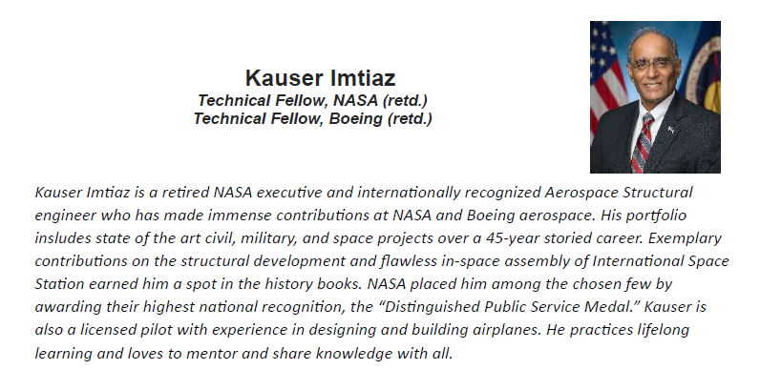
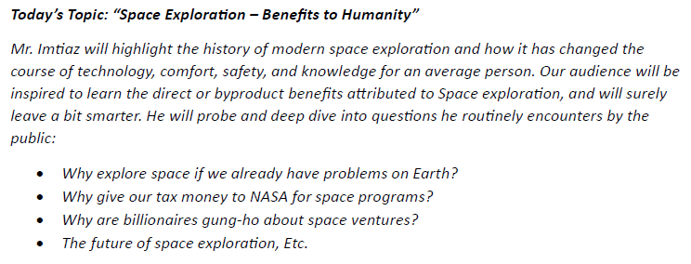

Humayun Kabir
Statutory regulations have a significant impact on the marine industry by driving higher standards in safety, environmental performance, and operational compliance. Recent updates—from stricter emission limits in areas like the Mediterranean SOx Emission Control Area and new greenhouse‑gas reduction frameworks, to enhanced safety rules under SOLAS and requirements such as harassment‑prevention training—are reshaping how ships are built, operated, and maintained. These regulations push companies to modernize fleets, adopt cleaner fuels, strengthen crew training, and invest in digital systems, ensuring safer, more sustainable, and more accountable maritime operations worldwide.
With more than four decades of maritime industry experience—including 24 years with ABS across permanent assignments in Singapore, China, and the United States—he currently serves as Senior Principal Surveyor within the Corporate Class group of the Chief Surveyor’s Office. Recognized across the industry as a leading SME on statutory compliance, he provides technical leadership on key regulatory frameworks including MARPOL, SOLAS, IHM, and Port State control matters. He holds a Chief Engineer License from the UK Maritime and Coastguard Agency and a Master of Business and Technology from the University of New South Wales, bringing together deep seagoing, technical, and managerial expertise. Prior to joining ABS, he served with Neptune Orient Lines and Ocean Tankers Singapore, gaining extensive operational and fleet management insights. Today, he represents ABS in the INTERTANKO Subcommittee, as well as at IMO SSE‑12 in coordination with the U.S. Coast Guard, and contributes to the IACS Port State Control Group—actively shaping international regulatory and compliance discussions that impact the global maritime community.
Syed Anwar
Syed Anwar is the Manager of Learning with ABS Corporate Learning, bringing over 35 years of maritime experience to the role. He began his career at sea as a Marine Chief Engineer and later spent more than 23 years in classification, serving across Southeast Asia, the Middle East, Africa, and the United States. His leadership journey includes roles as Principal Surveyor, Regional Lead Principal Auditor, and most recently Country Manager for Saudi Arabia and Kuwait. Today, he oversees the training and professional development of Surveyors, Auditors, and Engineers, supporting ABS in maintaining the highest standards of competence and technical excellence.

